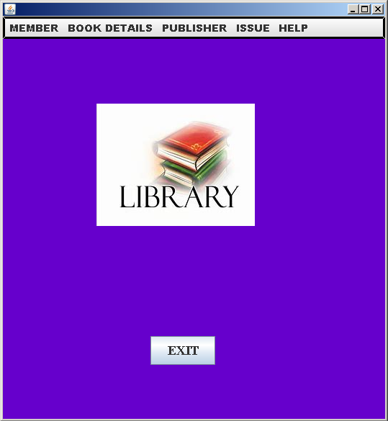

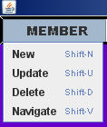

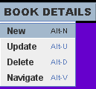



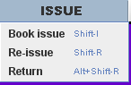



private void openMenuItemActionPerformed
(java.awt.event.ActionEvent evt) {

new Memnew().setVisible(true);
}

private void saveMenuItemActionPerformed
(java.awt.event.ActionEvent evt) {

new memmodi().setVisible(true);
}

private void jMenuItem8ActionPerformed
(java.awt.event.ActionEvent evt) {

new memdel().setVisible(true);
}

private void jMenuItem9ActionPerformed
(java.awt.event.ActionEvent evt) {

new memnavi().setVisible(true);
}

private void cutMenuItemActionPerformed
(java.awt.event.ActionEvent evt) {

new booknew().setVisible(true);

}

private void copyMenuItemActionPerformed(java.awt.event.ActionEvent evt) {

new bookmodi().setVisible(true); }

private void pasteMenuItemActionPerformed
(java.awt.event.ActionEvent evt) {

new bookdel().setVisible(true); }

private void deleteMenuItemActionPerformed
(java.awt.event.ActionEvent evt) {

new booknavi().setVisible(true);
}

private void jMenuItem4ActionPerformed
(java.awt.event.ActionEvent evt) {

new pubnew().setVisible(true);
}

private void jMenuItem5ActionPerformed
(java.awt.event.ActionEvent evt) {

new pubmodi().setVisible(true);
}

private void jMenuItem6ActionPerformed
(java.awt.event.ActionEvent evt) {

new pubbdel().setVisible(true);
}

private void jMenuItem10ActionPerformed
(java.awt.event.ActionEvent evt) {

new pubnavi().setVisible(true); }

private void jMenuItem1ActionPerformed
(java.awt.event.ActionEvent evt) {
new bookisue().setVisible(true);

}

private void jMenuItem2ActionPerformed
(java.awt.event.ActionEvent evt) {

new reissue().setVisible(true); }

private void jMenuItem3ActionPerformed
(java.awt.event.ActionEvent evt) {

new bookreturn().setVisible(true); }

private void contentMenuItemActionPerformed
(java.awt.event.ActionEvent evt)
{
new HELP1().setVisible(true); }

private void aboutMenuItemActionPerformed
(java.awt.event.ActionEvent evt)
{
new ABOUT().setVisible(true);
}

private void jButton1ActionPerformed
(java.awt.event.ActionEvent evt) {

System.exit(0);
}

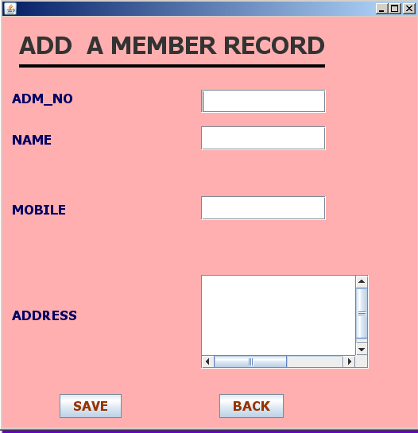

import java.awt.Color;

import java.sql.Connection;

import java.sql.DriverManager;

import java.sql.ResultSet;

import java.sql.Statement;

import javax.swing.JOptionPane;

private void jButton1ActionPerformed
(java.awt.event.ActionEvent evt) {

//SAVE BUTTON
{
String ad=adm.getText();

String nm=name.getText();

String mo=mob.getText();

String adr=adrs.getText();

if(ad.isEmpty()||adr.isEmpty()||mo.isEmpty()||nm.isEmpty())
{
JOptionPane.showMessageDialog(this,"YOU CAN NOT LEAVE ANY INFOPRMATION EMPTY!");

}
else
{
int b=JOptionPane.showConfirmDialog(this,"Do You Want To Save Record????");

if (b==0)

{ try

{
Class.forName("java.sql.DriverManager");

Connection C=(Connection)DriverManager.getConnection
("jdbc:mysql://localhost:3306/library","root","rrmps");

Statement s=(Statement)C.createStatement();

String q="Insert into member values('"+ad+"','"+nm+"','"+adr+" ','"+mo+"','not_issued');";

s.executeUpdate(q);

adm.setText("");

name.setText("");

adrs.setText("");

mob.setText("");

}
catch (Exception e)
{
JOptionPane.showMessageDialog(null,e.getMessage());
}}

if (b==1)
{
this.dispose();

}

}
}
}
private void admKeyTyped
(java.awt.event.KeyEvent evt) {

char a=evt.getKeyChar();

if(!((a>='0'&&'9'>=a)||(a==evt.VK_DELETE)||(a==evt.VK_BACK_SPACE)))

evt.consume(); }

private void mobKeyTyped(java.awt.event.KeyEvent evt) {

char a=evt.getKeyChar();

if(!((a>='0'&&'9'>=a)||(a==evt.VK_DELETE)||(a==evt.VK_BACK_SPACE)))

evt.consume(); }

private void nameKeyTyped(java.awt.event.KeyEvent evt) {

char a=evt.getKeyChar();

if(!((a>='a'&&'z'>=a)||(a==evt.VK_DELETE)||(a==evt.VK_BACK_SPACE)||(a>'A'&&'Z'>a)||(a==evt.VK_SPACE)))

evt.consume(); }

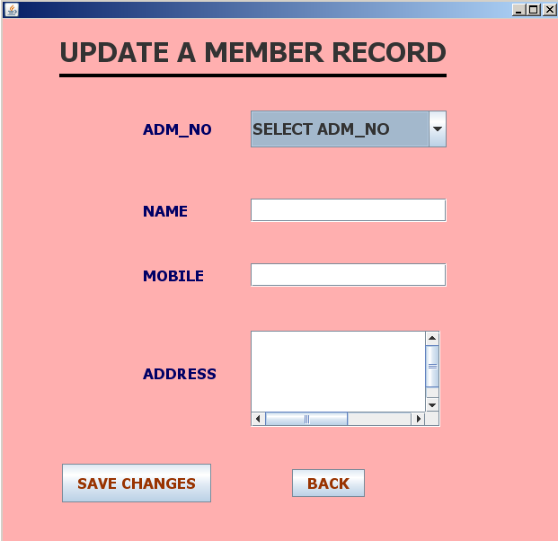

import com.mysql.jdbc.Connection;

import com.mysql.jdbc.Statement;

import java.awt.Color;

import java.sql.DriverManager;

import java.sql.ResultSet;

import javax.swing.JOptionPane;

private void jButton1ActionPerformed
(java.awt.event.ActionEvent evt) {

if(t2.getText().isEmpty()||t3.getText().isEmpty()||t5.getText().isEmpty())
{

JOptionPane.showMessageDialog

(null,"YOU CAN NOT LEAVE ANY INFOPRMATION EMPTY!");

}
else
{
String ad=(String)c1.getSelectedItem(),l,d,f;

l= t2.getText();

d=t3.getText();

f=t5.getText();

try
{
Class.forName("java.sql.DriverManager");

Connection C=(Connection)DriverManager.getConnection

("jdbc:mysql://localhost:3306/library","root","rrmps");

Statement s=(Statement)C.createStatement();

String q="DELETE from member WHERE ADM_NO ="+""+ad+";";

s.executeUpdate(q);

String w="Insert into member values

('"+ad+"','"+l+"','"+f+"','"+d+"','not_issued');";

s.executeUpdate(w);

}

catch (Exception e)
{

JOptionPane.showMessageDialog(null,e.getMessage());

}

JOptionPane.showMessageDialog(null,"CHANGES SAVED");

t2.setText("");

t3.setText("");

t5.setText("");

c1.setSelectedIndex(0);

}
}

private void formWindowOpened
(java.awt.event.WindowEvent evt) {

try
{
Class.forName("java.sql.DriverManager");

Connection C=(Connection)DriverManager.getConnection
("jdbc:mysql://localhost:3306/library","root","rrmps");

Statement s=(Statement)C.createStatement();

String q="select adm_no from member ;";

ResultSet rs=s.executeQuery(q);

while(rs.next())
{
String adm=rs.getString("adm_no");

c1.addItem(adm);
}
}
catch (Exception e)

{
JOptionPane.showMessageDialog(null,e.getMessage());
}
}

private void c1ActionPerformed
(java.awt.event.ActionEvent evt) {

int z=c1.getSelectedIndex();

if(z==0)

{ t2.setText("");

t3.setText("");

t5.setText("");}

else
{
String ad=(String)c1.getSelectedItem();
try
{
Class.forName("java.sql.DriverManager");

Connection C=(Connection)DriverManager.getConnection
("jdbc:mysql://localhost:3306/library","root","rrmps");

Statement s=(Statement)C.createStatement();

String q="select * from member where adm_no="+" "+ad+";";

ResultSet rs=s.executeQuery(q);

rs.next();

t2.setText(rs.getString("name"));

t5.setText(rs.getString("address"));

t3.setText(rs.getString("ph_no"));

}
catch(Exception e)

{
JOptionPane.showMessageDialog(null,e.getMessage());
}
t2.setEditable(true);

t3.setEditable(true);

t5.setEditable(true);

}
}

private void t3KeyTyped
(java.awt.event.KeyEvent evt) {

char a=evt.getKeyChar();

if(!((a>='0'&&'9'>=a)||(a==evt.VK_DELETE)||(a==evt.VK_BACK_SPACE)))

evt.consume();

}

private void t2KeyTyped
(java.awt.event.KeyEvent evt) {

char a=evt.getKeyChar();

if(!((a>='a'&&'z'>=a)||(a==evt.VK_DELETE)||(a==evt.VK_BACK_SPACE)||(a>='A'&&'Z'>=a)||(a==evt.VK_SPACE)))

evt.consume();

}

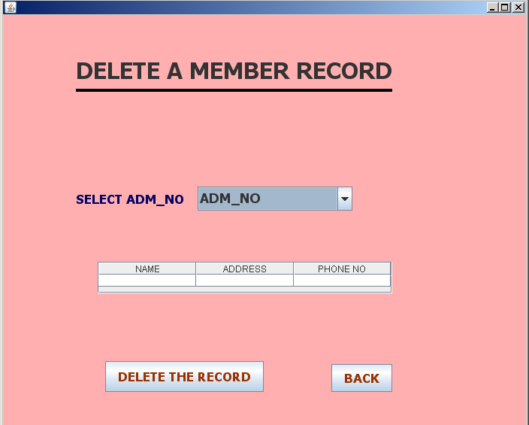

import java.awt.Color;

import java.sql.Connection;

import java.sql.DriverManager;

import java.sql.ResultSet;

import java.sql.Statement;

import javax.swing.JOptionPane;

import javax.swing.table.DefaultTableModel;

private void jButton1ActionPerformed
(java.awt.event.ActionEvent evt) {

String adm=(String)c1.getSelectedItem();

int b=JOptionPane.showConfirmDialog(null,"Do You Want To DELETE THE Record????");

if (b==0)
{
try
{
Class.forName("java.sql.DriverManager");

Connection C=(Connection)DriverManager.getConnection ("jdbc:mysql://localhost:3306/library","root","rrmps");

Statement s=(Statement)C.createStatement();

String q="delete from member where adm_no=('"+adm+"');";

s.executeUpdate(q);

int m=c1.getSelectedIndex();

c1.removeItemAt(m);

}
catch (Exception e)
{

JOptionPane.showMessageDialog(null,e.getMessage());

}
}
if (b==1)
{
this.dispose();
}
}

private void formWindowOpened
(java.awt.event.WindowEvent evt) {

try
{

Class.forName("java.sql.DriverManager");

Connection C=(Connection)DriverManager.getConnection ("jdbc:mysql://localhost:3306/library","root","rrmps");

Statement s=(Statement)C.createStatement();

String q="select adm_no from member ;";

ResultSet rs=s.executeQuery(q);

while(rs.next())
{

String adm=rs.getString("adm_no");

c1.addItem(adm);
}

}
catch (Exception e)
{

JOptionPane.showMessageDialog(null,e.getMessage());

}
tt1.setEnabled(false);

}

private void c1ActionPerformed
(java.awt.event.ActionEvent evt) {

int z=c1.getSelectedIndex();

if(z==0)
{

}

DefaultTableModel dm=(DefaultTableModel)tt1.getModel();

int a=dm.getRowCount();

while(a>0)
{

dm.removeRow(0);

a=dm.getRowCount();
}

String l=(String)c1.getSelectedItem();

try

{
Class.forName("java.sql.DriverManager");

Connection C=(Connection)DriverManager.getConnection ("jdbc:mysql://localhost:3306/LIBRARY","root","rrmps");

Statement s=(Statement)C.createStatement();

String q="select * from MEMBER where ADM_NO='"+l+"';";
ResultSet rs=s.executeQuery(q);

rs.next();

String st=rs.getString("status");

if(st.equals("not_issued"))
{
int sd=1;

while(sd<=1)
{

String at=rs.getString("name");

String p=rs.getString("address");

String e=rs.getString("ph_no");

dm.addRow(new Object[] {at,p,e});

sd++;
}

tt1.setModel(dm);
}

else if (st.equals("issued"))
{
JOptionPane.showMessageDialog(null,"THIS MEMBER ISSUED A BOOK!! YOU CAN'T DELETE...");

c1.setSelectedIndex(0);

}

}
catch (Exception e)
{
JOptionPane.showMessageDialog(null,e.getMessage());
}
}

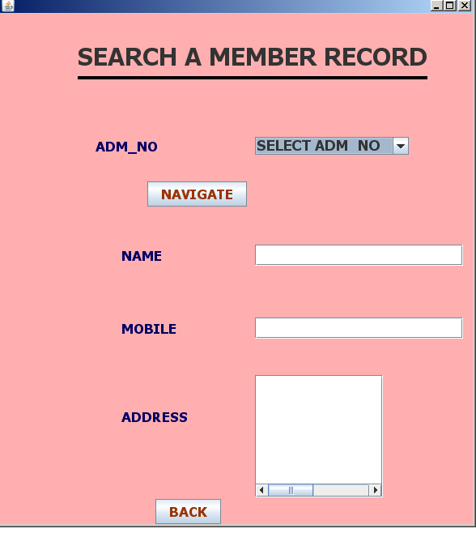

import com.mysql.jdbc.Connection;

import com.mysql.jdbc.Statement;

import java.awt.Color;

import java.sql.DriverManager;

import java.sql.ResultSet;

import javax.swing.JOptionPane;

private void jButton1ActionPerformed
(java.awt.event.ActionEvent evt) {

int z=c1.getSelectedIndex();

if(z==0)
{
t3.setText("");

t5.setText("");

t4.setText("");
}

else {

String ad=(String)c1.getSelectedItem();

try {
Class.forName("java.sql.DriverManager");

Connection C=(Connection)DriverManager.getConnection ("jdbc:mysql://localhost:3306/library","root","rrmps");

Statement s=(Statement)C.createStatement();

String q="select * from member where ADM_no= "+ad+";";

ResultSet rs=s.executeQuery(q);

rs.next();

t3.setText(rs.getString("name"));

t4.setText(rs.getString("ph_no"));

t5.setText(rs.getString("address"));

} catch(Exception e) {

JOptionPane.showMessageDialog(null,e.getMessage());
}

t5.setEditable(false);

t4.setEditable(false);

t3.setEditable(false);

}
}

private void jButton2ActionPerformed
(java.awt.event.ActionEvent evt) {
this.dispose();
}

private void formWindowOpened
(java.awt.event.WindowEvent evt) {
try
{

Class.forName("java.sql.DriverManager");

Connection C=(Connection)DriverManager.getConnection
("jdbc:mysql://localhost:3306/library","root","rrmps");

Statement s=(Statement)C.createStatement();

String q="select ADM_no from MEMBER ;";

ResultSet rs=s.executeQuery(q);

while(rs.next())
{
String adm=rs.getString("ADM_no");

c1.addItem(adm);
}
}
catch (Exception e)
{
JOptionPane.showMessageDialog(null,e.getMessage());
}
}

private void t3KeyTyped
(java.awt.event.KeyEvent evt) {

char a=evt.getKeyChar();
if(!((a>'a'&&'z'>a)||(a==evt.VK_DELETE)||(a==evt.VK_BACK_SPACE)

||(a>'A'&&'Z'>a)||(a==evt.VK_SPACE)))

evt.consume(); }

private void t5KeyTyped
(java.awt.event.KeyEvent evt) {

char a=evt.getKeyChar();

if(!((a>'a'&&'z'>a)||(a==evt.VK_DELETE)||(a==evt.VK_BACK_SPACE)

||(a>'A'&&'Z'>a)||(a==evt.VK_SPACE)))

evt.consume();

}

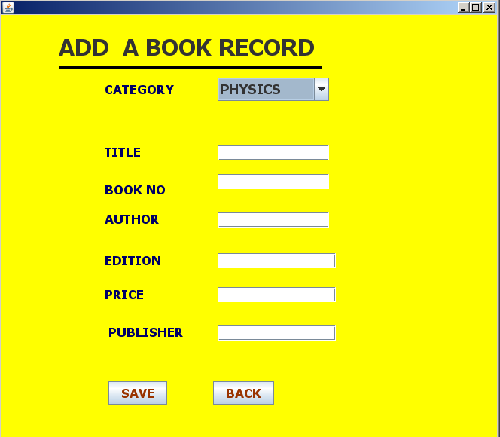

import com.mysql.jdbc.Connection;

import com.mysql.jdbc.Statement;

import java.awt.Color;

import java.sql.DriverManager;

import java.sql.ResultSet;

import javax.swing.*;

private void jButton1ActionPerformed
(java.awt.event.ActionEvent evt) {

if(a.getText().isEmpty()||b.getText().isEmpty()||e.getText().isEmpty()
||p.getText().isEmpty()||pb.getText().isEmpty()||t.getText().isEmpty())
{

JOptionPane.showMessageDialog(null,"YOU CAN NOT LEAVE ANY INFOPRMATION EMPTY!");
}

else
{
String cc=(String) c1.getSelectedItem();

String tl=t.getText();

String bn=b.getText();

String au=a.getText();

String ed=e.getText();

String pr=p.getText();

String pbl=pb.getText();

int x=JOptionPane.showConfirmDialog(null,"Do You Want To Save Record????");

if (x==0)

{try

{
Class.forName("java.sql.DriverManager");

Connection C=(Connection)DriverManager.getConnection
("jdbc:mysql://localhost:3306/library","root","rrmps");

Statement s=(Statement)C.createStatement();

String w="select almirah_no as a from category where books_cat='"+cc+"';";

ResultSet rs=s.executeQuery(w);

rs.next();

String alm=rs.getString("a");

String q="Insert into lib values('"+tl+"','"+au+"','"+pbl+" ','"+ed+"','"+pr+"','y','"+bn+"','"+cc+"','"+alm+"');";

s.executeUpdate(q);

String rr="select total_books as a from category where books_cat ='"+cc+"';";

ResultSet aa=s.executeQuery(rr);

aa.next();

int tb=aa.getInt("a");

tb++;

String tt="update category set total_books="+tb+" where books_cat ='"+cc+"';";

s.executeUpdate(tt);

e.setText("");

p.setText("");

pb.setText("");

- setText("");

t.setText("");

b.setText("");

}
catch (Exception en)
{

JOptionPane.showMessageDialog(null,en.getMessage());
}}

if (x==1)
{

this.dispose();
}}

}

private void formWindowOpened
(java.awt.event.WindowEvent evt) {

try
{

Class.forName("java.sql.DriverManager");

Connection C=(Connection)DriverManager.getConnection
("jdbc:mysql://localhost:3306/library","root","rrmps");

Statement s=(Statement)C.createStatement();

String q="select Books_cat from category ;";

ResultSet rs=s.executeQuery(q);

while(rs.next())
{
String adm=rs.getString("books_cat");

c1.addItem(adm);
}
}
catch (Exception e)
{

JOptionPane.showMessageDialog(null,e.getMessage());

}
}

private void bKeyTyped
(java.awt.event.KeyEvent evt) {

char a=evt.getKeyChar();

if(!((a>='0'&&'9'>=a)||(a==evt.VK_DELETE)||(a==evt.VK_BACK_SPACE)))

evt.consume();
}

private void eKeyTyped
(java.awt.event.KeyEvent evt) {
char a=evt.getKeyChar();

if(!((a>='0'&&'9'>=a)||(a==evt.VK_DELETE)||(a==evt.VK_BACK_SPACE)))

evt.consume();
}

private void pKeyTyped
(java.awt.event.KeyEvent evt) {
char a=evt.getKeyChar();

if(!((a>='0'&&'9'>=a)||(a==evt.VK_DELETE)||(a==evt.VK_BACK_SPACE)))

evt.consume();

private void tKeyTyped
(java.awt.event.KeyEvent evt) {

char a=evt.getKeyChar();

if(!((a>='a'&&'z'>=a)||(a==evt.VK_DELETE)||(a==evt.VK_BACK_SPACE)||(a>='A'&&'Z'>=a)||(a==evt.VK_SPACE)))

evt.consume();

}

private void aKeyTyped
(java.awt.event.KeyEvent evt) {
char a=evt.getKeyChar();

if(!((a>='a'&&'z'>=a)||(a==evt.VK_DELETE)||(a==evt.VK_BACK_SPACE)||(a>='A'&&'Z'>=a)||(a==evt.VK_SPACE)))

evt.consume();

}

private void pbKeyTyped
(java.awt.event.KeyEvent evt) {

char a=evt.getKeyChar();

if(!((a>='a'&&'z'>=a)||(a==evt.VK_DELETE)||(a==evt.VK_BACK_SPACE)||(a>='A'&&'Z'>=a)||(a==evt.VK_SPACE)))

evt.consume();

}

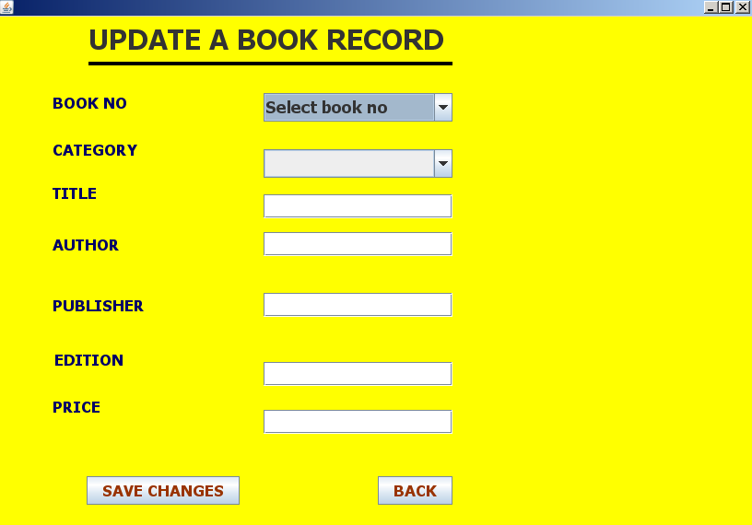

import com.mysql.jdbc.Connection;

import com.mysql.jdbc.Statement;

import java.awt.Color;

import java.sql.DriverManager;

import java.sql.ResultSet;

import javax.swing.JOptionPane;

private void jButton1ActionPerformed
(java.awt.event.ActionEvent evt) {

if(t1.getText().isEmpty()||t22.getText().isEmpty()||t3.getText().isEmpty()||t4.getText().isEmpty()||t5.getText().isEmpty())

{

JOptionPane.showMessageDialog(null,"YOU CAN NOT LEAVE ANY INFOPRMATION EMPTY!");

}
else
{

String bd=(String)c2.getSelectedItem();

String ad=(String)c1.getSelectedItem(),l,d,f,g,m;

g= t1.getText();

l= t22.getText();

d=t3.getText();

m=t4.getText();

f=t5.getText();

try
{

Class.forName("java.sql.DriverManager");

Connection C=(Connection)DriverManager.getConnection ("jdbc:mysql://localhost:3306/library","root","rrmps");

Statement s=(Statement)C.createStatement();

String qw="select almirah_no from category where books_cat= '"+bd+"';";

ResultSet rs=s.executeQuery(qw);

rs.next();

String pa=rs.getString("almirah_no");

String q="DELETE from lib WHERE book_NO ="+ad+";";

s.executeUpdate(q);

String w="Insert into lib values ('"+g+"','"+l+"','"+d+"','"+f+"','"+m+"','y','"+ad+"','"+bd+"','"+pa+"');";

System.out.print(w);

s.executeUpdate(w);

}
catch (Exception e)

{
JOptionPane.showMessageDialog(null,e.getMessage());

}
JOptionPane.showMessageDialog(null,"CHANGES SAVED");

t22.setText("");

t3.setText("");

t5.setText("");

t1.setText("");

t4.setText("");
}
}

private void c1ActionPerformed
(java.awt.event.ActionEvent evt) {

int z=c1.getSelectedIndex();

if(z==0)

{
t22.setText("");

t3.setText("");

t5.setText("");

t1.setText("");

t4.setText("");

}

else
{

String ad=(String)c1.getSelectedItem();

try

{
Class.forName("java.sql.DriverManager");

Connection C=(Connection)DriverManager.getConnection
("jdbc:mysql://localhost:3306/library","root","rrmps");

Statement s=(Statement)C.createStatement();

String q="select * from lib where book_no= "+ad+";";
ResultSet rs=s.executeQuery(q);

rs.next();

t1.setText(rs.getString("title"));

t22.setText(rs.getString("author"));

t3.setText(rs.getString("publisher"));

t5.setText(rs.getString("edition"));

t4.setText(rs.getString("price"));

}
catch(Exception e)
{
JOptionPane.showMessageDialog(null,e.getMessage());
}
t22.setEditable(true);

t3.setEditable(true);

t5.setEditable(true);

t1.setEditable(true);

t4.setEditable(true);

}

try
{

Class.forName("java.sql.DriverManager");

Connection C=(Connection)DriverManager.getConnection
("jdbc:mysql://localhost:3306/library","root","rrmps");

Statement s=(Statement)C.createStatement();

String q="select Books_cat from category ;";

ResultSet rs=s.executeQuery(q);

while(rs.next())
{

String adm=rs.getString("books_cat");

c2.addItem(adm);
}
}
catch (Exception e)

{
JOptionPane.showMessageDialog(null,e.getMessage());
}
}

private void formWindowOpened
(java.awt.event.WindowEvent evt) {

try

{
Class.forName("java.sql.DriverManager");

Connection C=(Connection)DriverManager.getConnection ("jdbc:mysql://localhost:3306/library","root","rrmps");

Statement s=(Statement)C.createStatement();

String q="select Book_no from lib ;";

ResultSet rs=s.executeQuery(q);

while(rs.next())
{
String adm=rs.getString("Book_no");

c1.addItem(adm);
}
}

catch (Exception e)
{
JOptionPane.showMessageDialog(null,e.getMessage());

} }

private void t5KeyTyped
(java.awt.event.KeyEvent evt) {
char a=evt.getKeyChar();

if(!((a>='0'&&'9'>=a)||(a==evt.VK_DELETE)||(a==evt.VK_BACK_SPACE)))

evt.consume();
}

private void t4KeyTyped
(java.awt.event.KeyEvent evt) {
char a=evt.getKeyChar();

if(!((a>='0'&&'9'>=a)||(a==evt.VK_DELETE)||(a==evt.VK_BACK_SPACE)))

evt.consume();
}

private void t1KeyTyped
(java.awt.event.KeyEvent evt) {
char a=evt.getKeyChar();

if(!((a>='a'&&'z'>=a)||(a==evt.VK_DELETE)||(a==evt.VK_BACK_SPACE)||(a>='A'&&'Z'>=a)||(a==evt.VK_SPACE)))

evt.consume();
}

private void t22KeyTyped
(java.awt.event.KeyEvent evt) {
char a=evt.getKeyChar();

if(!((a>='a'&&'z'>=a)||(a==evt.VK_DELETE)||(a==evt.VK_BACK_SPACE)||(a>='A'&&'Z'>=a)||(a==evt.VK_SPACE)))

evt.consume(); }

private void t3KeyTyped
(java.awt.event.KeyEvent evt) {

char a=evt.getKeyChar();

if(!((a>='a'&&'z'>=a)||(a==evt.VK_DELETE)||(a==evt.VK_BACK_SPACE)||(a>='A'&&'Z'>=a)||(a==evt.VK_SPACE)))

evt.consume();

}

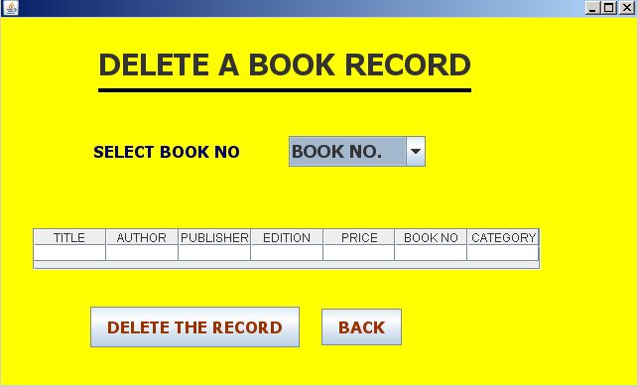

import com.mysql.jdbc.Connection;

import com.mysql.jdbc.Statement;

import java.awt.Color;

import java.sql.DriverManager;

import java.sql.ResultSet;

import javax.swing.JOptionPane;

import javax.swing.table.DefaultTableModel;

private void c1ActionPerformed
(java.awt.event.ActionEvent evt) {

int z=c1.getSelectedIndex();
if(z==0)
{

}

DefaultTableModel dm=(DefaultTableModel)tt1.getModel();

int a=dm.getRowCount();

while(a>0)
{
dm.removeRow(0);

a=dm.getRowCount();
}

String l=(String)c1.getSelectedItem();

try
{

Class.forName("java.sql.DriverManager");
Connection C=(Connection)DriverManager.getConnection
("jdbc:mysql://localhost:3306/LIBRARY","root","rrmps");

Statement s=(Statement)C.createStatement();

String q="select * from lib where book_no='"+l+"';";

ResultSet rs=s.executeQuery(q);

rs.next();

String st=rs.getString("status");

if(st.equals("y"))

{
int sd=1;

while(sd<=1)
{
String t=rs.getString("title");

String at=rs.getString("author");

String p=rs.getString("publisher");

String e=rs.getString("edition");

String pr=rs.getString("price");

String adm=rs.getString("book_no");

String cat=rs.getString("category");

dm.addRow(new Object[] {t,at,p,e,pr,adm,cat});

sd++;

}

tt1.setModel(dm);

}

else if (st.equals("N"))
{
JOptionPane.showMessageDialog(null,"BOOK ISSUED!!! YOU CAN'T DELETE...");

c1.setSelectedIndex(0);
}

}
catch (Exception e)
{
JOptionPane.showMessageDialog(null,e.getMessage());
}

}

private void formWindowOpened
(java.awt.event.WindowEvent evt) {

try
{
Class.forName("java.sql.DriverManager");

Connection C=(Connection)DriverManager.getConnection
("jdbc:mysql://localhost:3306/library","root","rrmps");

Statement s=(Statement)C.createStatement();

String q="select Book_no from lib ;";

ResultSet rs=s.executeQuery(q);

while(rs.next())
{
String adm=rs.getString("Book_no");

c1.addItem(adm);
}

}
catch (Exception e)
{
JOptionPane.showMessageDialog(null,e.getMessage());
}
tt1.setEnabled(false);
}

private void jButton1ActionPerformed
(java.awt.event.ActionEvent evt) {

String adm=(String)c1.getSelectedItem();

int b=JOptionPane.showConfirmDialog(null,"Do You Want To DELETE THE Record????");

if (b==0)
{
try
{
Class.forName("java.sql.DriverManager");

Connection C=(Connection)DriverManager.getConnection
("jdbc:mysql://localhost:3306/library","root","rrmps");

Statement s=(Statement)C.createStatement();

String ru="select category as a from lib where book_no ="+adm+";";

ResultSet ag=s.executeQuery(ru);

ag.next();

String ct=ag.getString("a");

String q="delete from lib where book_no=('"+adm+"');";

s.executeUpdate(q);

int m=c1.getSelectedIndex();

c1.removeItemAt(m);

String rr="select total_books as a from category where books_cat ='"+ct+"';";
ResultSet aa=s.executeQuery(rr);

aa.next();

int tb=aa.getInt("a");

tb--;

String tt="update category set total_books="+tb+" where books_cat ='"+ct+"';";

s.executeUpdate(tt);

}
catch (Exception e)
{
JOptionPane.showMessageDialog(null,e.getMessage());
}

}
if (b==1)
{
this.dispose();
}
}

private void jButton2ActionPerformed
(java.awt.event.ActionEvent evt)
{

this.dispose();
}

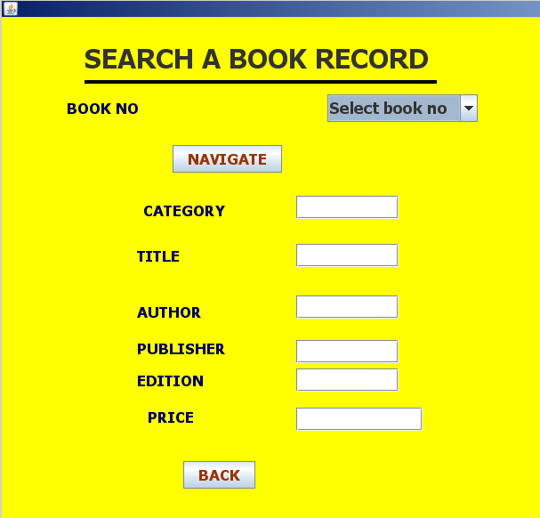

import com.mysql.jdbc.Connection;

import com.mysql.jdbc.Statement;

import java.awt.Color;

import java.sql.DriverManager;

import java.sql.ResultSet;

import javax.swing.JOptionPane;

private void jButton1ActionPerformed
(java.awt.event.ActionEvent evt) {

int z=c1.getSelectedIndex();

if(z==0)
{
t22.setText("");

t3.setText("");

t5.setText("");

t1.setText("");

t4.setText("");
}

else
{
String ad=(String)c1.getSelectedItem();

try
{
Class.forName("java.sql.DriverManager");

Connection C=(Connection)DriverManager.getConnection
("jdbc:mysql://localhost:3306/library","root","rrmps");

Statement s=(Statement)C.createStatement();

String q="select * from lib where book_no= "+ad+";";
ResultSet rs=s.executeQuery(q);

rs.next();

t1.setText(rs.getString("title"));

t22.setText(rs.getString("author"));

t3.setText(rs.getString("publisher"));

t5.setText(rs.getString("edition"));

t4.setText(rs.getString("price"));

t11.setText(rs.getString("category"));

}
catch(Exception e)
{
JOptionPane.showMessageDialog(null,e.getMessage());
}

t22.setEditable(false);

t5.setEditable(false);

t1.setEditable(false);

t4.setEditable(false);

t3.setEditable(false);

t11.setEditable(false);

}
}

private void formWindowOpened
(java.awt.event.WindowEvent evt) {

try
{

Class.forName("java.sql.DriverManager");
Connection C=(Connection)DriverManager.getConnection
("jdbc:mysql://localhost:3306/library","root","rrmps");

Statement s=(Statement)C.createStatement();

String q="select Book_no from lib ;";

ResultSet rs=s.executeQuery(q);

while(rs.next())
{
String adm=rs.getString("Book_no");

c1.addItem(adm);
}
}
catch (Exception e)

{

JOptionPane.showMessageDialog(null,e.getMessage());

}
}

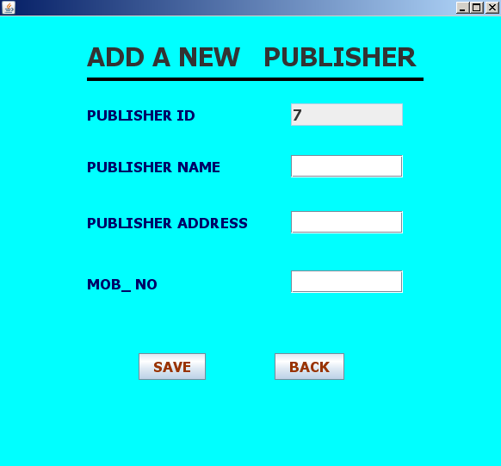

i
mport com.mysql.jdbc.Connection;

import com.mysql.jdbc.Statement;

import java.awt.Color;

import java.sql.DriverManager;

import java.sql.ResultSet;

import javax.swing.JOptionPane;

private void jButton3ActionPerformed
(java.awt.event.ActionEvent evt) {
if(t1.getText().isEmpty()||t2.getText().isEmpty()||t3.getText().isEmpty()||t4.getText().isEmpty())

{
JOptionPane.showMessageDialog(null,"YOU CAN NOT LEAVE ANY INFOPRMATION EMPTY!");

}

else
{
{
String id=t1.getText();

String nm=t2.getText();

String mo=t3.getText();

String adr=t4.getText();

int b=JOptionPane.showConfirmDialog(null,"Do You Want To Save Record????");

if (b==0)
{

try
{
Class.forName("java.sql.DriverManager");

Connection C=(Connection)DriverManager.getConnection
("jdbc:mysql://localhost:3306/library","root","rrmps");

Statement s=(Statement)C.createStatement();

String q="Insert into publisher values('"+id+"','"+nm+"','"+mo+" ','"+adr+"');";

s.executeUpdate(q);

String w="select max(pub_id) as a from publisher;";

ResultSet rs =s.executeQuery(w);

rs.next();

int dd=rs.getInt("a");

dd++;

t1.setText(""+dd);

t1.setEditable(false);

t2.setText("");

t3.setText("");

t4.setText("");

} catch (Exception e)
{
JOptionPane.showMessageDialog(null,e.getMessage());
}}

if (b==1) {
this.dispose();

}} } }

private void formWindowOpened
(java.awt.event.WindowEvent evt)
{
try
{
Class.forName("java.sql.DriverManager");

Connection C=(Connection)DriverManager.getConnection
("jdbc:mysql://localhost:3306/library","root","rrmps");

Statement s=(Statement)C.createStatement();

String w="select max(pub_id) as a from publisher;";

ResultSet rs =s.executeQuery(w);

rs.next();

int id=rs.getInt("a");

id++;

t1.setText(""+id);

t1.setEditable(false);

}
catch (Exception e)
{
JOptionPane.showMessageDialog(null,e.getMessage());
}
}

private void t4KeyTyped
(java.awt.event.KeyEvent evt) {

char a=evt.getKeyChar();

if(!((a>='0'&&'9'>=a)||(a==evt.VK_DELETE)||(a==evt.VK_BACK_SPACE)))

evt.consume(); }

private void t2KeyTyped
(java.awt.event.KeyEvent evt) {

char a=evt.getKeyChar();

if(!((a>='a'&&'z'>=a)||(a==evt.VK_DELETE)||(a==evt.VK_BACK_SPACE)||(a>='A'&&'Z'>=a)||(a==evt.VK_SPACE)))

evt.consume();

}

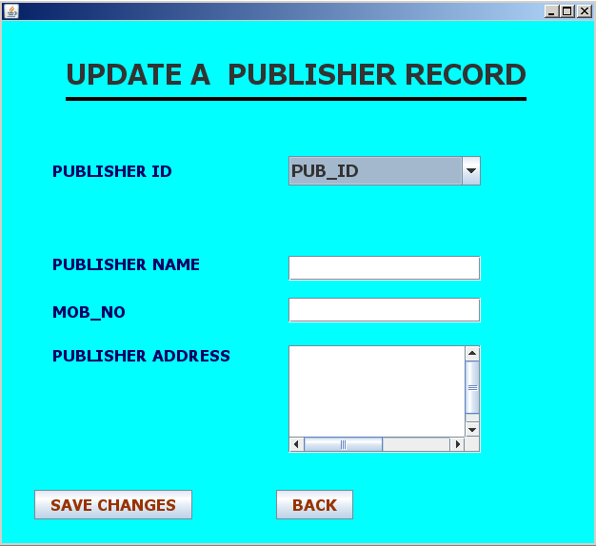

import com.mysql.jdbc.Connection;

import com.mysql.jdbc.Statement;

import java.awt.Color;

import java.sql.DriverManager;

import java.sql.ResultSet;

import javax.swing.JOptionPane;

private void jButton1ActionPerformed
(java.awt.event.ActionEvent evt) {

if(t1.getText().isEmpty()||t2.getText().isEmpty()||t3.getText().isEmpty())
{

JOptionPane.showMessageDialog(null,"YOU CAN NOT LEAVE ANY INFOPRMATION EMPTY!");

}

else
{
String ad=(String)c1.getSelectedItem(),l,d,f;

l= t2.getText();

d=t3.getText();

f=t1.getText();

try

{

Class.forName("java.sql.DriverManager");

Connection C=(Connection)DriverManager.getConnection
("jdbc:mysql://localhost:3306/library","root","rrmps");

Statement s=(Statement)C.createStatement();

String q="DELETE from publisher WHERE pub_id ='"+ad+"';";

s.executeUpdate(q);

String w="Insert into publisher values('"+ad+"','"+f+"','"+d+"','"+l+"');";

s.executeUpdate(w);
}

catch (Exception e)
{

JOptionPane.showMessageDialog(null,e.getMessage());

}

JOptionPane.showMessageDialog(null,"CHANGES SAVED");

t2.setText("");

t3.setText("");

t1.setText("");

c1.setSelectedIndex(0);

}
}

private voidformWindowOpened
(java.awt.event.WindowEvent evt) {

try
{
Class.forName("java.sql.DriverManager");

Connection C=(Connection)DriverManager.getConnection
("jdbc:mysql://localhost:3306/library","root","rrmps");

Statement s=(Statement)C.createStatement();

String q="select pub_id from publisher;";

ResultSet rs=s.executeQuery(q);

while(rs.next())
{

String adm=rs.getString("pub_id");

c1.addItem(adm);
}

}

catch (Exception e)
{

JOptionPane.showMessageDialog(null,e.getMessage());

}
}

private void c1ActionPerformed
(java.awt.event.ActionEvent evt) {

int z=c1.getSelectedIndex();

if(z==0) {

t2.setText("");

t3.setText("");

t1.setText("");
}

else {

String ad=(String)c1.getSelectedItem();

try
{

Class.forName("java.sql.DriverManager");

Connection C=(Connection)DriverManager.getConnection
("jdbc:mysql://localhost:3306/library","root","rrmps");

Statement s=(Statement)C.createStatement();

String q="select * from publisher where pub_id= '"+ad+"';";

ResultSet rs=s.executeQuery(q);

rs.next();

t1.setText(rs.getString("pub_name"));

t3.setText(rs.getString("pub_address"));

t2.setText(rs.getString("mob_no"));

}
catch(Exception e)
{

JOptionPane.showMessageDialog(null,e.getMessage());
}

t2.setEditable(true);

t3.setEditable(true);

t1.setEditable(true);

}
}

private void t2KeyTyped
(java.awt.event.KeyEvent evt) {

char a=evt.getKeyChar();

if(!((a>='0'&&'9'>=a)||(a==evt.VK_DELETE)||(a==evt.VK_BACK_SPACE)))

evt.consume(); }

private void t1KeyTyped
(java.awt.event.KeyEvent evt) {

char a=evt.getKeyChar();
if(!((a>='a'&&'z'>=a)||(a==evt.VK_DELETE)||(a==evt.VK_BACK_SPACE)||(a>='A'&&'Z'>=a)||(a==evt.VK_SPACE)))

evt.consume(); }

private void t3KeyTyped
(java.awt.event.KeyEvent evt) {

char a=evt.getKeyChar();
if(!((a>='a'&&'z'>=a)||(a==evt.VK_DELETE)||(a==evt.VK_BACK_SPACE)||(a>='A'&&'Z'>=a)||(a==evt.VK_SPACE)))

evt.consume(); }

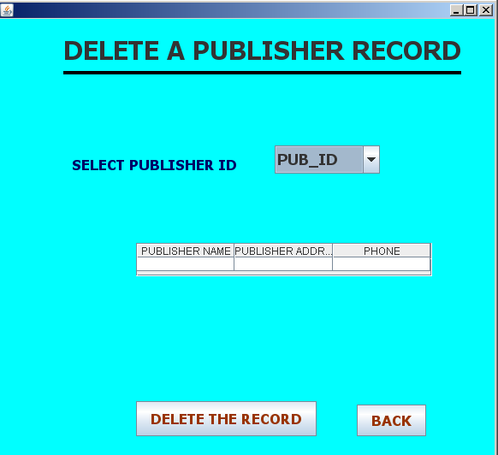

import com.mysql.jdbc.Connection;

import com.mysql.jdbc.Statement;

import java.awt.Color;

import java.sql.DriverManager;

import java.sql.ResultSet;

import javax.swing.JOptionPane;

import javax.swing.table.DefaultTableModel;

private void jButton1ActionPerformed
(java.awt.event.ActionEvent evt) {

String adm=(String)c1.getSelectedItem();

int b=JOptionPane.showConfirmDialog(null,"Do You Want To DELETE THE Record????");

if (b==0)

{
try
{
Class.forName("java.sql.DriverManager");

Connection C=(Connection)DriverManager.getConnection
("jdbc:mysql://localhost:3306/library","root","rrmps");

Statement s=(Statement)C.createStatement();

String q="delete from publisher where pub_id=('"+adm+"');";

s.executeUpdate(q);

int m=c1.getSelectedIndex();

c1.removeItemAt(m);

}
catch (Exception e)
{

JOptionPane.showMessageDialog(null,e.getMessage());

}
}
if (b==1)
{
this.dispose();
}
}

private void c1ActionPerformed
(java.awt.event.ActionEvent evt) {

int z=c1.getSelectedIndex();

if(z==0)

{

}
else
{

DefaultTableModel dm=(DefaultTableModel)tt1.getModel();

int a=dm.getRowCount();

while(a>0)
{
dm.removeRow(0);

a=dm.getRowCount();
}

String l=(String)c1.getSelectedItem();

try
{
Class.forName("java.sql.DriverManager");

Connection C=(Connection)DriverManager.getConnection
("jdbc:mysql://localhost:3306/LIBRARY","root","rrmps");

Statement s=(Statement)C.createStatement();

String q="select * from publisher where pub_id='"+l+"';";

ResultSet rs=s.executeQuery(q);

rs.next();

String t=rs.getString("pub_name");

String at=rs.getString("pub_address");

String p=rs.getString("mob_no");

dm.addRow(new Object[] {t,at,p});

tt1.setModel(dm);

}
catch (Exception e)
{

JOptionPane.showMessageDialog(null,e.getMessage());

} }
}

private void formWindowOpened
(java.awt.event.WindowEvent evt) {

try
{

Class.forName("java.sql.DriverManager");

Connection C=(Connection)DriverManager.getConnection
("jdbc:mysql://localhost:3306/library","root","rrmps");

Statement s=(Statement)C.createStatement();

String q="select pub_id from publisher;";

ResultSet rs=s.executeQuery(q);

while(rs.next())

{
String adm=rs.getString("pub_id");

c1.addItem(adm);
}
}
catch (Exception e)
{

JOptionPane.showMessageDialog(null,e.getMessage());
}
tt1.setEnabled(false);
}

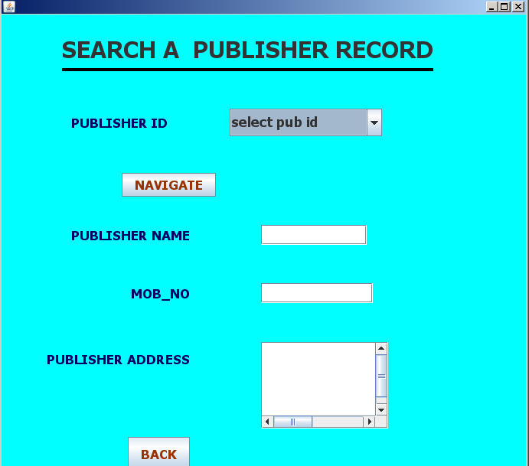

import com.mysql.jdbc.Connection;

import com.mysql.jdbc.Statement;

import java.awt.Color;

import java.sql.DriverManager;

import java.sql.ResultSet;

import javax.swing.JOptionPane;

private void jButton1ActionPerformed
(java.awt.event.ActionEvent evt) {

int z=c1.getSelectedIndex();

if(z==0)
{
t2.setText("");

t3.setText("");

t1.setText("");
}

else
{
String ad=(String)c1.getSelectedItem();

try
{
Class.forName("java.sql.DriverManager");

Connection C=(Connection)DriverManager.getConnection
("jdbc:mysql://localhost:3306/library","root","rrmps");

Statement s=(Statement)C.createStatement();

String q="select * from publisher where pub_id= '"+ad+"';";

ResultSet rs=s.executeQuery(q);

rs.next();

t1.setText(rs.getString("pub_name"));

t3.setText(rs.getString("pub_address"));

t2.setText(rs.getString("mob_no"));

}
catch(Exception e)
{
JOptionPane.showMessageDialog(null,e.getMessage());

}
t2.setEditable(false);

t3.setEditable(false);

t1.setEditable(false);

}

}

private void jButton2ActionPerformed
(java.awt.event.ActionEvent evt) {

this.dispose();
}

private void formWindowOpened
(java.awt.event.WindowEvent evt) {

try
{
Class.forName("java.sql.DriverManager");

Connection C=(Connection)DriverManager.getConnection
("jdbc:mysql://localhost:3306/library","root","rrmps");

Statement s=(Statement)C.createStatement();

String q="select pub_id from publisher ;";

ResultSet rs=s.executeQuery(q);

while(rs.next())
{
String adm=rs.getString("pub_id");

c1.addItem(adm);
}
}
catch (Exception e)
{

JOptionPane.showMessageDialog(null,e.getMessage());
}

}

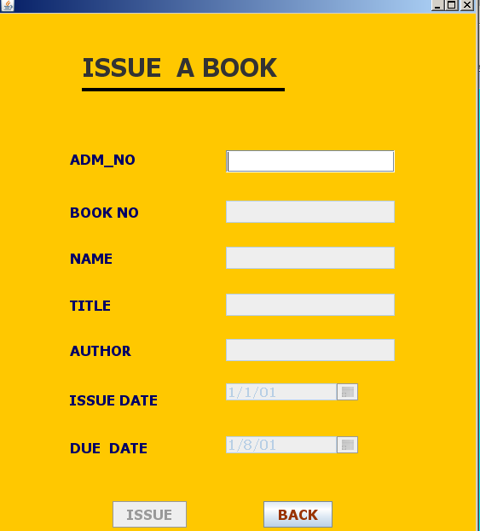

import com.mysql.jdbc.Connection;

import com.mysql.jdbc.Statement;

import java.awt.Color;

import java.sql.DriverManager;

import java.sql.ResultSet;

import java.util.Calendar;

import javax.swing.JOptionPane;

private void t2ActionPerformed
(java.awt.event.ActionEvent evt) {

int x=Integer.parseInt(t2.getText());

try
{
Class.forName("java.sql.DriverManager");

Connection C=(Connection)DriverManager.getConnection
("jdbc:mysql://localhost:3306/library","root","rrmps");

Statement s=(Statement)C.createStatement();

String w="select TITLE,AUTHOR from LIB where book_no="+x+";";

ResultSet rs=s.executeQuery(w);

rs.next();

String a=rs.getString("TITLE");

String b=rs.getString("Author");

t4.setText(a);

t5.setText(b);

KK.setEnabled(true);
}
catch (Exception en)
{
JOptionPane.showMessageDialog(null,"BOOK DOES NOT EXIST!!");
}

}

private void KKActionPerformed
(java.awt.event.ActionEvent evt) {

if(t.getText().isEmpty()||t2.getText().isEmpty()||t3.getText().isEmpty()||t4.getText().isEmpty()||t5.getText().isEmpty())

{
JOptionPane.showMessageDialog(null,"YOU CAN NOT LEAVE ANY INFOPRMATION EMPTY!");

}
else

{

int x=Integer.parseInt(t2.getText());

int ad=Integer.parseInt(t.getText());

Calendar fd=(Calendar)d.getSelectedDate();

Calendar mm=(Calendar)d1.getSelectedDate();

String ff=fd.get(fd.YEAR)+"-"+(fd.get(fd.MONTH)+1)+"-"+ fd.get(fd.DAY_OF_MONTH);

String fm=mm.get(mm.YEAR)+"-"+(mm.get(mm.MONTH)+1)+"-"+ mm.get(mm.DAY_OF_MONTH);

try
{
Class.forName("java.sql.DriverManager");

Connection C=(Connection)DriverManager.getConnection
("jdbc:mysql://localhost:3306/library","root","rrmps");
Statement s=(Statement)C.createStatement();

String dd="select status from LIB where book_no="+x+";";

ResultSet rss=s.executeQuery(dd);

rss.next();

String a=rss.getString("status");

String b="SELECT status FROM Member WHERE ADM_NO="+ad+";";

ResultSet rs=s.executeQuery(b);

rs.next();

String n=rs.getString("status");

if (a.equals("N"))
{
JOptionPane.showMessageDialog(null,"BOOK IS ALREADY ISSUED");

t4.setText("");

t5.setText("");

t2.setText("");
}
else if(n.equals("issued"))
{
JOptionPane.showMessageDialog(null,"YOU CAN NOT ISSUE ANOTHER BOOK");

t.setText("");

t3.setText("");
}
else
{

String pq="Insert into missue values
('"+ff+"',NULL,"+x+","+ad+",'"+fm+"',0);";

s.executeUpdate(pq);

String gd="update lib set status = 'N' where book_no="+x+";";

s.executeUpdate(gd);

String bd="update member set status = 'issued' where adm_no="+ad+";";

s.executeUpdate(bd);

JOptionPane.showMessageDialog(null,"book has been issued");

t2.setText("");

t3.setText("");

t.setText("");

t4.setText("");

t5.setText("");

t2.setEditable(false);

t3.setEditable(false);

t4.setEditable(false);

t5.setEditable(false);

KK.setEnabled(false);
}

}
catch (Exception en)
{
JOptionPane.showMessageDialog(null,en.getMessage());
}
}

}

private void formWindowOpened
(java.awt.event.WindowEvent evt) {

try
{
Class.forName("java.sql.DriverManager");

Connection C=(Connection)DriverManager.getConnection
("jdbc:mysql://localhost:3306/library","root","rrmps");

Statement s=(Statement)C.createStatement();

String q="select year(curdate()) as a,month(curdate()) as m,day(curdate()) as y;";

ResultSet rs=s.executeQuery(q);

rs.next();

int dd,yy,mm;

dd=rs.getInt("y");

yy=rs.getInt("a");

mm=rs.getInt("m");

Calendar z=Calendar.getInstance();

z.set(yy,mm-1,dd);

d.setSelectedDate(z);

Calendar x=Calendar.getInstance();

x.set(yy,mm-1,dd+7);

d1.setSelectedDate(x);

}
catch (Exception e)
{
JOptionPane.showMessageDialog(null,e.getMessage());
}
d.setEnabled(false);

d1.setEnabled(false);

t2.setEditable(false);

t3.setEditable(false);

t4.setEditable(false);

t5.setEditable(false);

KK.setEnabled(false);
}

private void tActionPerformed
(java.awt.event.ActionEvent evt) {

int x=Integer.parseInt(t.getText());

try
{
Class.forName("java.sql.DriverManager");

Connection C=(Connection)DriverManager.getConnection
("jdbc:mysql://localhost:3306/library","root","rrmps");

Statement s=(Statement)C.createStatement();

String w="select name from member where adm_no="+x+";";

ResultSet rs=s.executeQuery(w);

rs.next();

String a=rs.getString("name");

t3.setText(a);

t2.setEditable(true);
}
catch (Exception en)
{
JOptionPane.showMessageDialog(null,"MEMBER DOES NOT EXIST!!"); }}

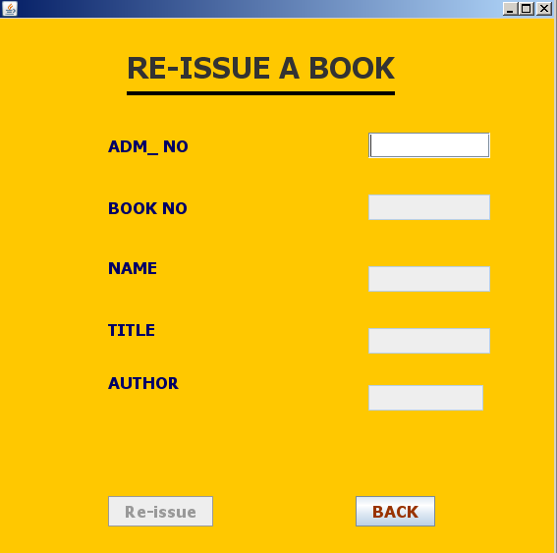

import com.mysql.jdbc.Connection;

import com.mysql.jdbc.Statement;

import java.awt.Color;

import java.sql.DriverManager;

import java.sql.ResultSet;

import java.util.Calendar;

import javax.swing.JOptionPane;

private void tActionPerformed
(java.awt.event.ActionEvent evt) {

int x=Integer.parseInt(t.getText());
try
{
Class.forName("java.sql.DriverManager");

Connection C=(Connection)DriverManager.getConnection
("jdbc:mysql://localhost:3306/library","root","rrmps");

Statement s=(Statement)C.createStatement();

String w="select name from member where adm_no="+x+";";

ResultSet rs=s.executeQuery(w);

rs.next();

String a=rs.getString("name");

t3.setText(a);

String q="select book_no from missue where adm_no="+x+";";

ResultSet rss=s.executeQuery(q);

rss.next();

String aa=rss.getString("book_no");

t2.setText(aa);

int f=Integer.parseInt(t2.getText());

String dw="select TITLE,AUTHOR from LIB where book_no="+aa+";";

ResultSet ras=s.executeQuery(dw);

ras.next();

String da=ras.getString("TITLE");

String b=ras.getString("Author");

t4.setText(da);

t5.setText(b);

String aq="select year(curdate()) as a,month(curdate()) as m,day(curdate()) as y;";

ResultSet rqs=s.executeQuery(aq);

rqs.next();

int dd,yy,mm;

dd=rqs.getInt("y");

yy=rqs.getInt("a");

mm=rqs.getInt("m");

Calendar z=Calendar.getInstance();

z.set(yy,mm-1,dd);

String ff=z.get(z.YEAR)+"-"+(z.get(z.MONTH)+1)+"-"+ z.get(z.DAY_OF_MONTH);

String xq="UPDATE MISSUE SET RETURN_DATE ='"+ff+"' WHERE adm_no="+x+";";

s.executeUpdate(xq);

KK.setEnabled(true);

}
catch (Exception en) {

JOptionPane.showMessageDialog(null,"No any book issued by this adm no. !!!!");
}
}

private void jButton3ActionPerformed
(java.awt.event.ActionEvent evt) {

this.dispose(); }

private void KKActionPerformed
(java.awt.event.ActionEvent evt) {
if(t.getText().isEmpty()||t2.getText().isEmpty()||t3.getText().isEmpty()||t4.getText().isEmpty()||t5.getText().isEmpty())

{
JOptionPane.showMessageDialog(null,"YOU CAN NOT LEAVE ANY INFOPRMATION EMPTY!");

}
else
{
int x=Integer.parseInt(t.getText());

try {
Class.forName("java.sql.DriverManager");

Connection C=(Connection)DriverManager.getConnection
("jdbc:mysql://localhost:3306/library","root","rrmps");

Statement s=(Statement)C.createStatement();

String q="Select year(due_date),month(due_date),day(due_date) from missue where adm_no="+x+";";

ResultSet rs=s.executeQuery(q);

rs.next();

int dd=rs.getInt("day(due_date)");

int dm=rs.getInt("month(due_date)");

int dy=rs.getInt("year(due_date)");

String w="Select year(return_date),month(return_date),day(return_date) from missue where adm_no="+x+";";

ResultSet rss=s.executeQuery(w);

rss.next();

int rd=rss.getInt("day(return_date)");

int rm=rss.getInt("month(return_date)");

int ry=rss.getInt("year(return_date)");

String y="Select dayofyear(return_date) from missue where adm_no="+x+";";
ResultSet r=s.executeQuery(y);

r.next();

int rdy=r.getInt("dayofyear(return_date)");

String ya="Select dayofyear(due_date) from missue where adm_no="+x+";";

ResultSet tt=s.executeQuery(ya);

tt.next();

int ddy=tt.getInt("dayofyear(due_date)");

int fine=0,d;

if (dy==ry)
{
fine=rdy-ddy;
}
else

{
int a,b;

a=ddy;

b=(a%400==0||(a%4==0&&a%100!=0))?1:0;

if (b==1)
{
d=366-ddy;

fine=rdy+d;

}
else if(b==0)
{
d=365-ddy;

fine=rdy+d;

}
}
if (fine>0)

{
String dc="update missue set fine="+fine+" where adm_no="+x+";";

s.executeUpdate(dc);

}
else
{
String adc="update missue set fine=0 where adm_no="+x+";";

s.executeUpdate(adc);
}

String k="Select year(due_date),month(due_date),day(due_date) from missue where adm_no="+x+";";

ResultSet rzs=s.executeQuery(k);

rzs.next();

int ddd=rzs.getInt("day(due_date)");

int m=rzs.getInt("month(due_date)");

int dddy=rzs.getInt("year(due_date)");

Calendar ad =Calendar.getInstance();

ad.set(dddy,m-1,ddd+7);

String ff=ad.get(ad.YEAR)+"-"+(ad.get(ad.MONTH)+1)+"-"+ ad.get(ad.DAY_OF_MONTH);

String gg="update missue set due_date='"+ff+"' where adm_no="+x+";";

s.executeUpdate(gg);

t2.setText("");

t3.setText("");

t.setText("");

t4.setText("");

t5.setText("");

t2.setEditable(false);

t3.setEditable(false);

t4.setEditable(false);

t5.setEditable(false);

KK.setEnabled(false);

}
catch (Exception en) {
JOptionPane.showMessageDialog(null,en.getMessage());

}}
}

private void formWindowOpened
(java.awt.event.WindowEvent evt) {

t2.setEditable(false);

t3.setEditable(false);

t4.setEditable(false);

t5.setEditable(false);

KK.setEnabled(false);

}

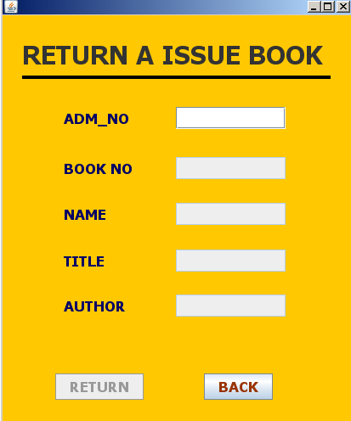

import com.mysql.jdbc.Connection;

import com.mysql.jdbc.Statement;

import java.awt.Color;

import java.sql.DriverManager;

import java.sql.ResultSet;

import java.util.Calendar;

import javax.swing.JOptionPane;

int x=Integer.parseInt(t.getText());

try
{

Class.forName("java.sql.DriverManager");

Connection C=(Connection)DriverManager.getConnection(
"jdbc:mysql://localhost:3306/library","root","rrmps");

Statement s=(Statement)C.createStatement();

String w="select name from member where adm_no="+x+";";

ResultSet rs=s.executeQuery(w);

rs.next();

String a=rs.getString("name");

t3.setText(a);

String q="select book_no from missue where adm_no="+x+";";

ResultSet rss=s.executeQuery(q);

rss.next();

String aa=rss.getString("book_no");

t2.setText(aa);

int f=Integer.parseInt(t2.getText());

String dw="select TITLE,AUTHOR from LIB where book_no="+aa+";";

ResultSet ras=s.executeQuery(dw);

ras.next();

String da=ras.getString("TITLE");

String b=ras.getString("Author");

t4.setText(da);

t5.setText(b);

String aq="select year(curdate()) as a,month(curdate()) as m,day(curdate()) as y;";

ResultSet rqs=s.executeQuery(aq);

rqs.next();

int dd,yy,mm;

dd=rqs.getInt("y");

yy=rqs.getInt("a");

mm=rqs.getInt("m");

Calendar z=Calendar.getInstance();

z.set(yy,mm-1,dd);

String ff=z.get(z.YEAR)+"-"+(z.get(z.MONTH)+1)+"-"+ z.get(z.DAY_OF_MONTH);

String xq="UPDATE MISSUE SET RETURN_DATE ='"+ff+"' WHERE adm_no="+x+";";

s.executeUpdate(xq);

KK.setEnabled(true);

}
catch (Exception en)
{
JOptionPane.showMessageDialog(null,"No any book issued by this adm no. !!!");

}
}
}

private void jButton3ActionPerformed
(java.awt.event.ActionEvent evt) {

this.dispose();
}

private void KKActionPerformed
(java.awt.event.ActionEvent evt) {

if(t.getText().isEmpty()||t2.getText().isEmpty()||t3.getText().isEmpty()||t4.getText().isEmpty()||t5.getText().isEmpty())

{
JOptionPane.showMessageDialog(null,"YOU CAN NOT LEAVE ANY INFOPRMATION EMPTY!");

}
else
{
String ad=t.getText();

String x=t2.getText();

try
{
Class.forName("java.sql.DriverManager");

Connection C=(Connection)DriverManager.getConnection
("jdbc:mysql://localhost:3306/library","root","rrmps");

Statement s=(Statement)C.createStatement();

String q="Select year(due_date),month(due_date),day(due_date) from missue where adm_no="+ad+";";

ResultSet rs=s.executeQuery(q);

rs.next();

int dd=rs.getInt("day(due_date)");

int dm=rs.getInt("month(due_date)");

int dy=rs.getInt("year(due_date)");

String w="Select year(return_date),month(return_date),day(return_date) from missue where adm_no="+ad+";";

ResultSet rss=s.executeQuery(w);

rss.next();

int rd=rss.getInt("day(return_date)");

int rm=rss.getInt("month(return_date)");

int ry=rss.getInt("year(return_date)");

String y="Select dayofyear(return_date) from missue where adm_no="+ad+";";

ResultSet r=s.executeQuery(y);

r.next();

int rdy=r.getInt("dayofyear(return_date)");

String ya="Select dayofyear(due_date) from missue where adm_no="+ad+";";

ResultSet tt=s.executeQuery(ya);

tt.next();

int ddy=tt.getInt("dayofyear(due_date)");

String dc="select fine from missue where adm_no="+ad+";";

ResultSet ra=s.executeQuery(dc);

ra.next();

int f=ra.getInt("fine");

int fine=0,d;

if (dy==ry)
{
fine=rdy-ddy+f;
}
else
{
int a,b;

a=ddy;

b=(a%400==0||(a%4==0&&a%100!=0))?1:0;

if (b==1)

{
d=366-ddy;

fine=rdy+d+f;
}
else if(b==0)
{
d=365-ddy;

fine=rdy+d+f;
}
}
if (fine>0)
{
JOptionPane.showMessageDialog(null,"YOU fined of RS"+fine);
}

else
{
JOptionPane.showMessageDialog(null,"YOUR BOOK HAS BEEN RETURNED");
}

String gd="update lib set status = 'y' where book_no="+x+";";

s.executeUpdate(gd);

String bd="update member set status = 'not_issued' where
adm_no="+ad+";";

s.executeUpdate(bd);

String aq="delete from missue where adm_no="+ad+";";

s.executeUpdate(aq);

t2.setText("");

t3.setText("");

t.setText("");

t4.setText("");

t5.setText("");

t2.setEditable(false);

t3.setEditable(false);

t4.setEditable(false);

t5.setEditable(false);

KK.setEnabled(false);

}
catch (Exception e)
{
JOptionPane.showMessageDialog(null,e.getMessage());
}}
}

private void formWindowOpened
(java.awt.event.WindowEvent evt) {

t2.setEditable(false);

t3.setEditable(false);

t4.setEditable(false);

t5.setEditable(false);

KK.setEnabled(false);
}

private void tKeyTyped
(java.awt.event.KeyEvent evt) {

char a=evt.getKeyChar();

if(!((a>='0'&&'9'>=a)||(a==evt.VK_DELETE)||(a==evt.VK_BACK_SPACE)))

evt.consume();

private void t2KeyTyped
(java.awt.event.KeyEvent evt) {

char a=evt.getKeyChar();

if(!((a>='0'&&'9'>=a)||(a==evt.VK_DELETE)||(a==evt.VK_BACK_SPACE)))

evt.consume();

}

private void t5KeyTyped
(java.awt.event.KeyEvent evt) {

char a=evt.getKeyChar();

if(!((a>='a'&&'z'>=a)||(a==evt.VK_DELETE)||(a==evt.VK_BACK_SPACE)||(a>='A'&&'Z'>=a)||(a==evt.VK_SPACE)))

evt.consume();
}

private void t4KeyTyped
(java.awt.event.KeyEvent evt) {

char a=evt.getKeyChar();
if(!((a>='a'&&'z'>=a)||(a==evt.VK_DELETE)||(a==evt.VK_BACK_SPACE)||(a>='A'&&'Z'>=a)||(a==evt.VK_SPACE)))

evt.consume();
}

private void t3KeyTyped
(java.awt.event.KeyEvent evt) {

char a=evt.getKeyChar();
if(!((a>='a'&&'z'>=a)||(a==evt.VK_DELETE)||(a==evt.VK_BACK_SPACE)||(a>='A'&&'Z'>=a)||(a==evt.VK_SPACE)))

evt.consume();
}

private void formWindowActivated
(java.awt.event.WindowEvent evt) {

getContentPane().setBackground(Color.orange);

}

